**JS ENGINE**

* **JS ENGINE**: It is a program or an integral part of a web browser that interprets and executes JS code. It translates human-readable JavaScript code into machine code. JS engines are responsible for running JavaScript applications on various platforms, and they play a crucial role in the performance and functionality of web browsers.
* V8 (Google Chrome): Open-source JS engine developed by Chromium project in C++.
* SpiderMonkey (Mozilla Firefox): It is also open-source.
* JavaScriptCore (Safari): Also known as Nitro & is open source
* Chakra (Microsoft Edge): Now using Blink, Chakra has been deprecated.
* These engines are designed to optimize the execution of JavaScript code, employing various techniques such as just-in-time (JIT) compilation, which converts JavaScript code into machine code at runtime for improved performance. Additionally, they implement features like garbage collection to manage memory efficiently.
* JS engines are not limited to browsers; they are also used in server-side environments (e.g., Node.js) to execute JS code outside the browser context. This versatility allows developers to use the same language for both client-side and server-side development.

**CALL STACK**

* It is a key component of the language's runtime environment. It keeps track of the execution context & function calls in a program. Let's break down how CS works in JS:
* **Function Invocation**: When a JS program starts running, an initial function (typically the global function or the function associated with the script) is added to the call stack;
* **Function Calls**: If this initial function calls another function, that function is added to the top of the call stack, representing the current execution context. This process continues as functions call other functions, creating a stack of execution contexts;
* **Execution**: The JavaScript engine executes the statements within the currently active function on the top of the call stack.
* **Function Completion**: When a function completes its execution, it is removed (popped) from the call stack, and control returns to the function that invoked it.
* **LIFO (Last In, First Out)**: The call stack follows the Last In, First Out principle. The most recently added function is the first to complete and be removed.
* Call stack is a data structure that the engine uses to keep track of the execution context and function calls.
* When a script is executed, the JavaScript engine creates the initial call stack frame for the main function or global code. As functions are called, additional frames are pushed onto the call stack, representing the current execution context. When a function completes its execution, its frame is popped off the stack, and control returns to the calling function.
* Call stack maintains the order of execution of the execution context.
* **JS engine creates the call stack, when code is executed global execution context is created & pushed to call stack.**

**EXECUTION CONTEXT**

* Everything in JS happens inside the execution context. Imagine a sealed-off container inside which JS runs. It is an abstract concept that holds info about the env. within the current code is being executed.
* 1st component is the memory component and the 2nd one is the code component.

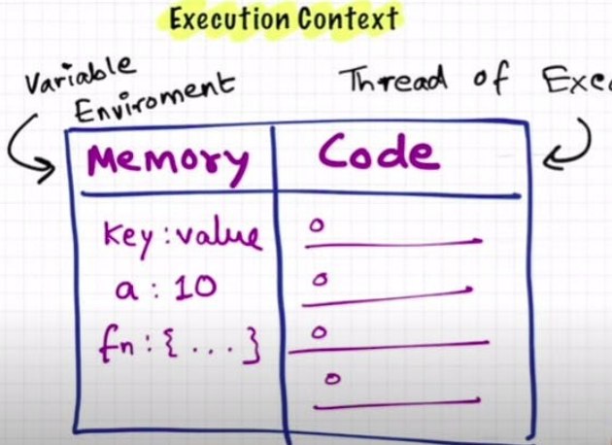

* Memory component has all the variables and functions in key value pairs. It is also called Variable environment.
* Code component is the place where code is executed one line at a time. It is also called the Thread of Execution.
* JS is synchronous(one command at a time), single-threaded(in a specific synchronous order) language.

**JS EXECUTION & CALL STACK**

* When a JS program runs, a global execution context is created. The execution context (EC) is created in two phases: Memory creation phase (JS will allocate memory to variables and function) and. Code execution phase
* Let's consider the below example and its code execution steps:
* The very first thing which JS does is memory creation phase, so it goes to line one of above code snippets, and allocates a memory space for variable 'n' and then goes to line two, and allocates a memory space for function 'square'. When allocating memory for n it stores 'undefined', a special value for 'n'. For 'square', it stores the whole code of the function inside its memory space. Then, as square2 and square4 are variables as well, it allocates memory and stores 'undefined' for them, and this is the end of the first phase i.e. memory creation phase. So O/P will look something like

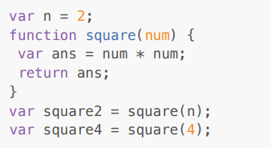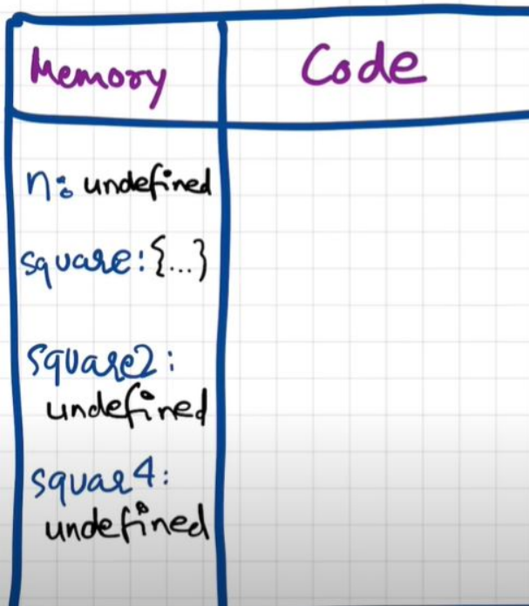

* Now, in the 2nd phase i.e. code execution phase, it starts going through the whole code line by line. As it encounters var n = 2, it assigns 2 to 'n'. Until now, the value of 'n' was undefined. For function, there is nothing to execute. As these lines were already dealt with in the memory creation phase.
* Coming to line 6 i.e. var square2 = square(n), here functions are a bit different than any other language. A new execution context (EC) is created altogether. Again in this new EC, in the memory creation phase, we allocate memory to num and ans the two variables. & undefined is placed in them. Now, in the code execution phase of this EC, first 2 is assigned to num. Then var ans = num * num will store 4 in ans. After that, return ans returns the control of program back to where this function was invoked from.

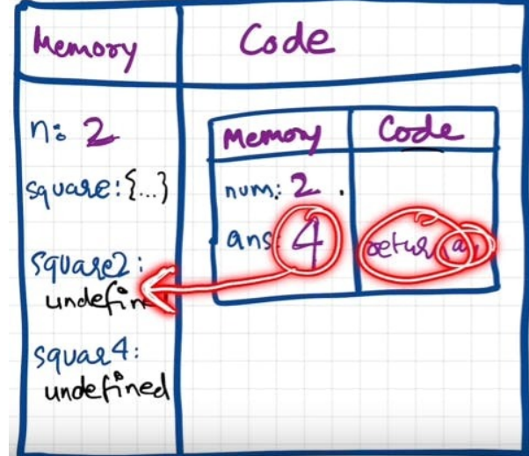

* When the return keyword is encountered, it returns the control to the called line and also the function EC is deleted.
* Same thing will be repeated for square4 and then after that is finished, the global EC will be destroyed. So the final diagram before deletion would look something like:

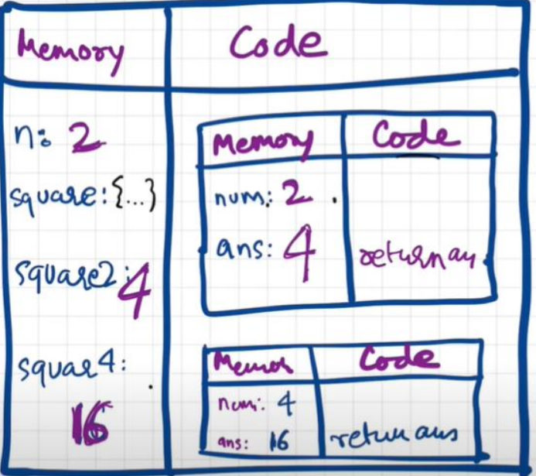

* Javascript manages code EC creation and deletion with the help of Call Stack (CS).
* CS is a mechanism to keep track of its place in a script that calls multiple functions.
* Call Stack maintains the order of execution of execution contexts. It is also known as Program Stack, Control Stack, Runtime stack, Machine Stack, Execution context stack.

**HOISTING**

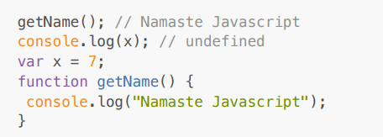

* It should have been an outright error in many other languages, as it is not possible to even access something which is not even created (defined) yet But in JS, We know that in the memory creation phase it assigns undefined and puts the content of function to function's memory. And in execution, it then executes whatever is asked. Here, as execution goes line by line and not after compiling, it could only print undefined and nothing else. This phenomenon is not an error. However, if we remove var x = 7; then it gives an error. Uncaught ReferenceError: x is not defined
* Hoisting is a concept which enables us to extract values of variables and functions even before initializing/assigning value without getting error and this is happening due to the 1st phase (memory creation phase) of the Execution Context.
* We learnt that execution context gets created in two phases, so even before code execution, memory is created so in case of variable, it will be initialized as undefined while in case of function the whole function code is placed in the memory. Example:

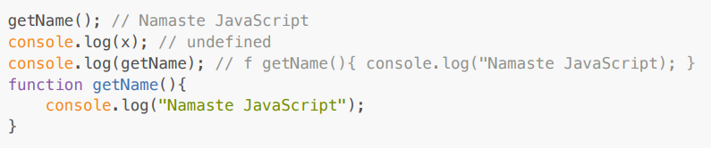

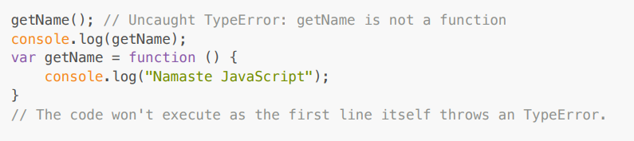

**FUNCTIONS & VARIABLE ENVIRONMENT**

* **Code Flow in terms of Execution Context**

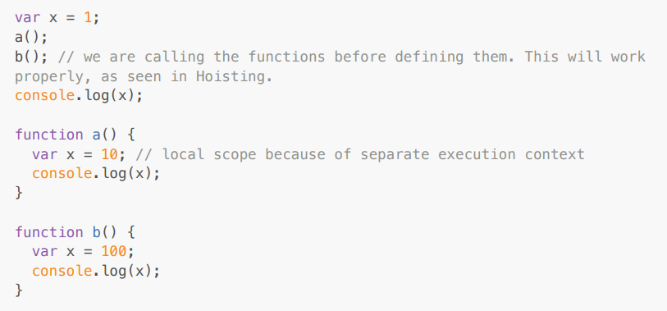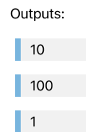

* The Global Execution Context (GEC) is created (the big box with Memory and Code subparts). Also GEC is pushed into Call Stack ⇒ **Call Stack : GEC**
* In the first phase of GEC (memory phase), variable x:undefined and a and b have their entire function code as value initialized In the second phase of GEC, when the function is called, a new local Execution Context is created. After x = 1 assigned to GEC x, a() is called. So local EC for a is made inside the code part of GEC. ⇒ **Call Stack: [GEC, a()]**
* For local EC, a totally different x variable is assigned undefined(x inside a()) in phase 1 , and in phase 2 it is assigned 10 and printed in console log. After printing, no more commands to run, so a() local EC is removed from both GEC and from Call stack ⇒ **Call Stack: GEC**
* Cursor goes back to the b() function call. Same steps repeat. ⇒ **Call Stack :[GEC, b()] -> GEC (after printing yet another totally different x value as 100 in console log)**
* Finally GEC is deleted and also removed from the call stack. Program ends.

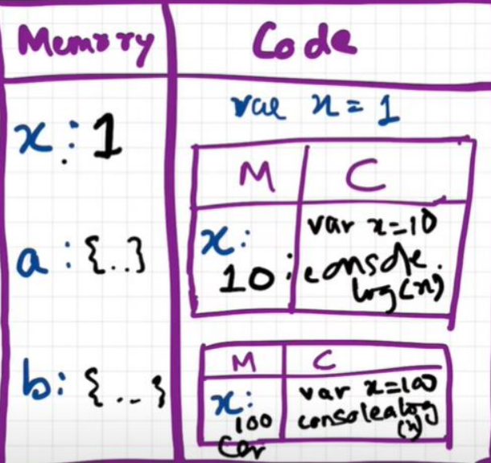

**WINDOW & THIS**

* The shortest JS program is an empty file. Because even then, the JS engine does a lot of things. Even in this case, it creates the GEC which has memory space and the EC.
* The JS engine creates something known as 'window'. It is an object, which is created in the global space. It contains lots of functions and variables. These functions and variables can be accessed from anywhere in the program. JS engine also creates this keyword, which points to the window object at the global level. So, in summary, along with GEC, a global object (window) and a ‘this’ variable are created.
* In different engines, the name of the global object changes. Window in browsers, but in nodeJS it is called something else. At global level, this === window
* If we create any variable in the global scope, then the variables get attached to the global object. Anything which is not inside function is a global space.

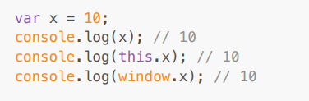

**UNDEFINED VS NOT DEFINED VS NULL**

* In the first phase (memory allocation) JS assigns each variable a placeholder ‘undefined’.
* undefined is when memory is allocated for the variable, but no value is assigned yet.
* If an object/variable is not even declared/found in memory allocation phase, and tries to access it then it is Not defined; **Not Defined !== Undefined**
* When a variable is declared but not assigned value, its current value is undefined. But when the variable itself is not declared but called in code, then it is not defined.

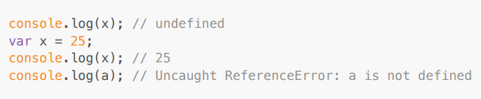

* JS is a loosely typed / weakly typed language. It doesn't attach variables to any datatype. We can say var a = 5, & then change the value to boolean or string a = 'hello' later on.
* Never assign undefined to a variable manually. Let it happen on its own accord.
* **typeof undefined = undefined** => undefined is a primitive data type.
* **typeof null = object.** null is a primitive data type
* null == undefined : **true** (both represent nothing-ness)
* null === undefined : **false** (both have different data types)

**SCOPE CHAIN**

* Scope in Javascript is directly related to Lexical Environment.

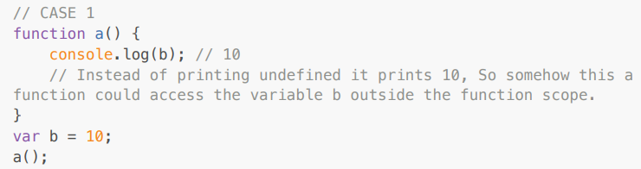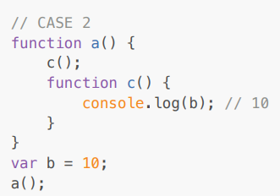

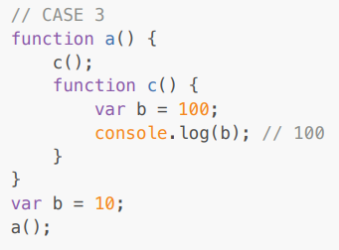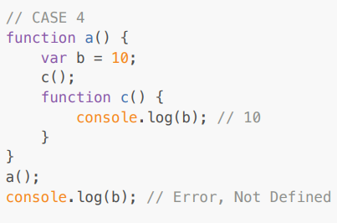

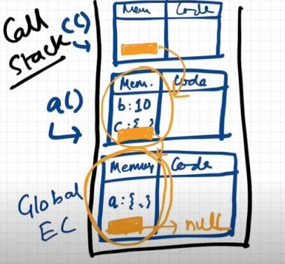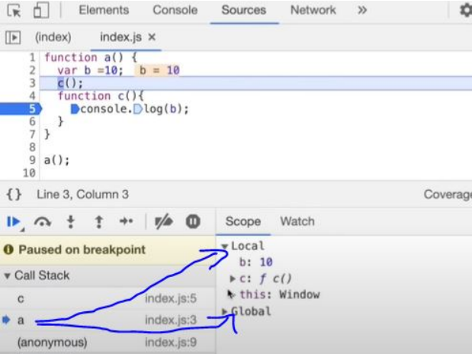

* Case 1: function a is able to access variable b from Global scope.
* Case 2: 10 is printed. It means that within the nested function too, the global scope variable can be accessed.
* Case 3: 100 is printed meaning the local variable of the same name took precedence over a global variable.
* Case 4: A function can access a global variable, but the global execution context can't access any local variable

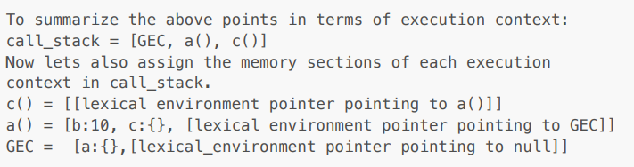

* So, **Lexical Environment** = local memory + lexical env of its parent. Hence, the Lexical Environment is the local memory along with the lexical environment of its parent.
* Lexical means In hierarchy, In order; Scope means: where we can access specific variable or function in our code
* Whenever an Execution Context is created, a Lexical environment(LE) is also created and is referenced in the local Execution Context(in memory space).
* The process of going one by one to the parent and checking for values is called scope chain or Lexical environment chain.

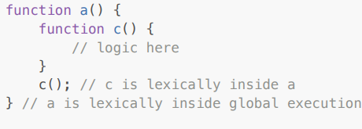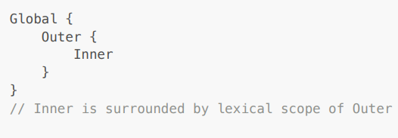

* Lexical or Static scope refers to the accessibility of variables, functions and objects based on physical location in source code.
* An inner function can access variables which are in outer functions even if the inner function is nested deep. In any other case, a function can't access variables not in its scope.

**LET, CONST & TEMPORAL DEAD ZONE**

* let and const declarations are hoisted. But it's different from var

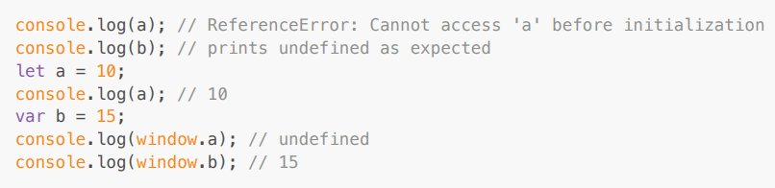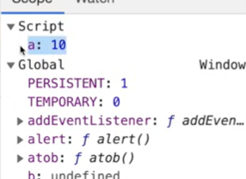

* Both a and b are actually initialized as undefined in the hoisting stage. But var b is inside the storage space of GLOBAL, and a is in a separate memory object called script, where it can be accessed only after assigning some value to it first ie. one can access 'a' only if it is assigned. Thus, it throws an error.
* **Temporal Dead Zone** : Time since when the let variable was hoisted until it is initialized to some value. Any line till before "let a = 10" is the TDZ for a Since a is not accessible on global, it's not accessible in window/this also. window.b or this.b -> 15; But window.a or this.a ->undefined, just like window.x->undefined (x isn't declared anywhere)
* Reference errors are thrown when variables are in a temporal dead zone.
* Syntax Error doesn't even let us run a single line of code.

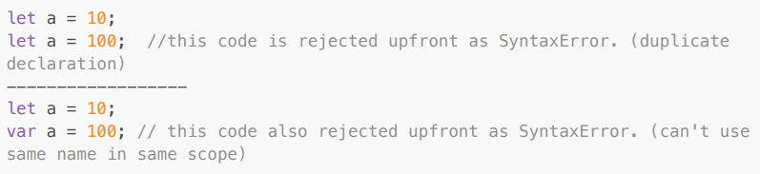

* Let is a stricter version of var. Now, const is even more stricter than let.

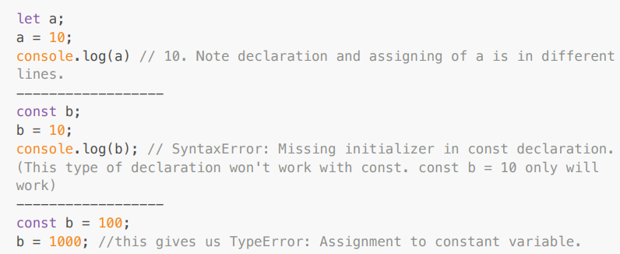

* Uncaught ReferenceError(URE): x is not defined: This Error signifies that x has never been in the scope of the program. This literally means that x was never defined/declared and is being tried to be accessed.
* URE: cannot access 'a' before initialization: This Error signifies that 'a' cannot be accessed because it is declared as 'let' and since it is not assigned a value, it is its Temporal Dead Zone. Thus, this error occurs.
* Uncaught SyntaxError: Identifier 'a' has already been declared: This Error signifies that we are redeclaring a variable that is 'let' declared. No execution will take place.
* Uncaught SyntaxError: Missing initializer in const declaration: This Error signifies that we haven't initialized or assigned value to a const declaration.
* Uncaught TypeError: Assignment to constant variable: This Error signifies that we are reassigning to a const variable.
* GOOD PRACTICES: Try using const wherever possible. If not, use let, avoid var. Declare & initialize all variables on top to avoid errors to shrink TDZ window to zero.

**BLOCK SCOPE & SHADOWING**

* Block aka compound statement is used to group JS statements together into 1 group. We group them within {...}

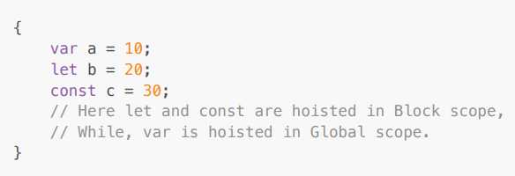

* Block Scope and its accessibility example

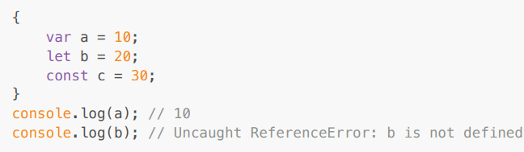

* In the BLOCK SCOPE; we get b and c inside it initialized as *undefined* as a part of hoisting (in a separate memory space called **block**) * While, a is stored inside a GLOBAL scope.
* Thus we say, *let* and *const* are BLOCK SCOPED. They are stored in a separate memory space which is reserved for this block. Also, they can't be accessed outside this block. But var a can be accessed anywhere as it is in global scope. Thus, we can't access them outside the Block.
* What is Shadowing?

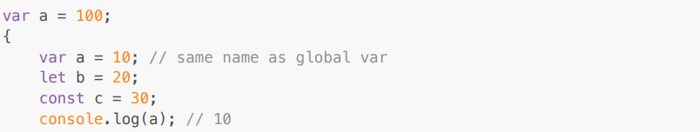

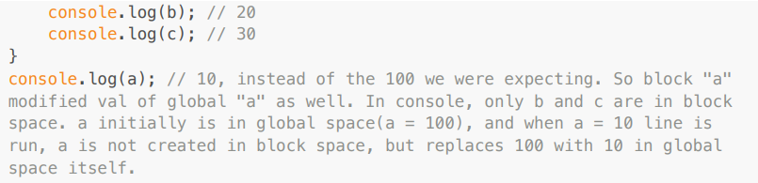

* So, If one has the same named variable outside the block, the variable inside the block shadows the outside variable. This happens only for var
* Let's observe the behavior in case of let and const and understand it's reason

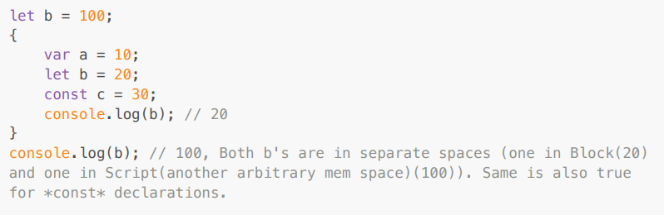

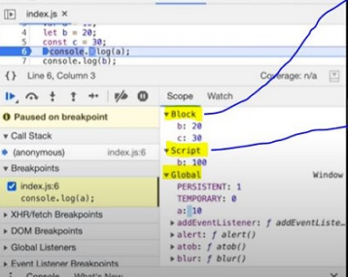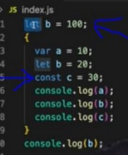

* Same logic is true even for functions

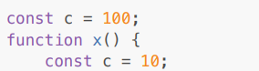

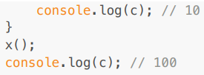

* What is Illegal Shadowing?

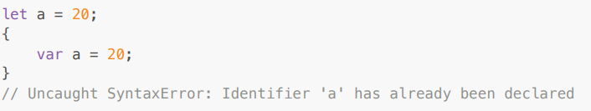

* We cannot shadow let with var. But it is valid to shadow a let using a let. However, we can shadow var with let.
* All scope rules that work in function are the same in arrow functions too.
* Since var is function scoped, it is not a problem with the code below (var will not illegally shadow the let inside the fun).

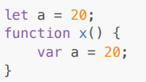

**CLOSURES**

* Function bundled along with its lexical scope is closure.
* JavaScript has a lexical scope environment. If a function needs to access a variable, it first goes to its local memory. When it does not find it there, it goes to the memory of its lexical parent. See Below code, Over here function y along with its lexical scope i.e. (function x) would be called a closure.

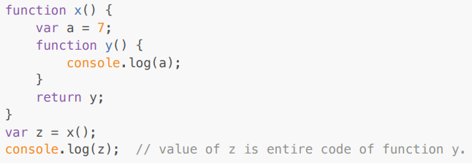

* In above code, When y is returned, not only is the function returned but the entire closure (func y + its lexical scope) is returned and put inside z. So when z is used somewhere else in the program, it still remembers var a inside x().
* A closure is a function that has access to its outer function scope even after the function has returned. Meaning, A closure can remember and access variables and arguments reference of its outer function even after the function has returned.

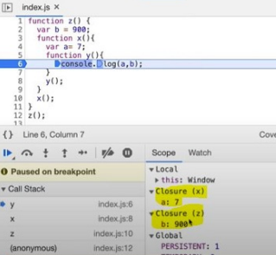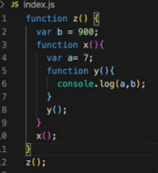

* **Advantages**: Module Design Pattern, Currying, Functions like once, Memoize, Maintaining state in async, Data hiding and encapsulation, Iterators, setTimeouts etc.
* **Disadvantage**: Over consumption of memory Memory Leak Freeze browser

**SET TIMEOUT & CLOSURES**

* We expect JS to wait 3 sec, print 1 and then go down and print the string. But JS prints string immediately, waits 3 sec and then prints 1.

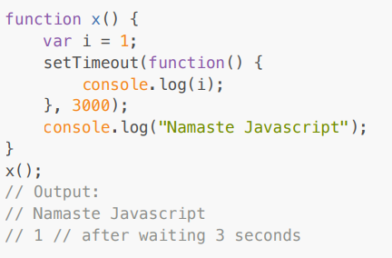

* The function inside setTimeout forms a closure (remembers reference to i). So wherever function goes it carries this ref along with it.
* setTimeout takes this callback function & attaches a timer of 3000ms and stores it. Goes to the next line without waiting and prints the string.
* After 3000ms runs out, JS takes the function, puts it into the call stack and runs it.
* Q: Print 1 after 1 sec, 2 after 2 sec till 5 : Tricky interview question We assume this has a simple approach as below

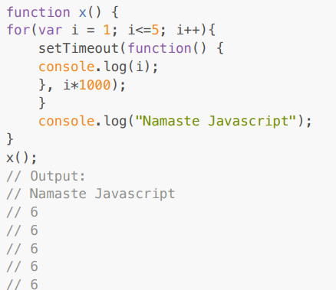

* Why? This happens because of closures. When setTimeout stores the function somewhere and attaches a timer to it, the function remembers its reference to i, not value of i. All 5 copies of the function point to the same reference of i. JS stores these 5 functions, prints string and then comes back to the functions. By then the timer had run fully. And due to looping, the i value became 6. And when the callback fun runs the variable i = 6. So the same 6 is printed in each log To avoid this, we can use let instead of var as let has Block scope. For each iteration, the i is a new variable altogether(new copy of i). Everytime setTimeout is run, the inside function forms closure with new variable i
* But what if the interviewer asks us to implement using var?

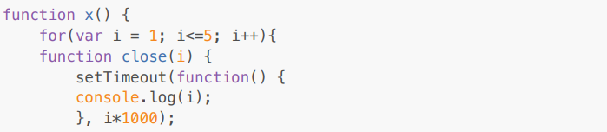

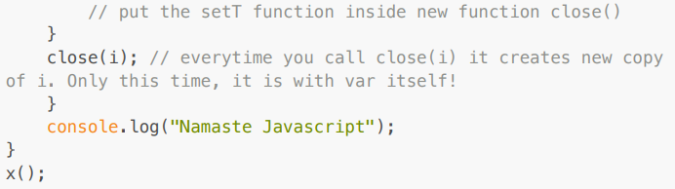

**CLOSURES INTERVIEW QUES**

* **What is Closure in Javascript?** A function along with reference to its outer environment together forms a closure. Or in other words, A Closure is a combination of a function and its lexical scope bundled together.

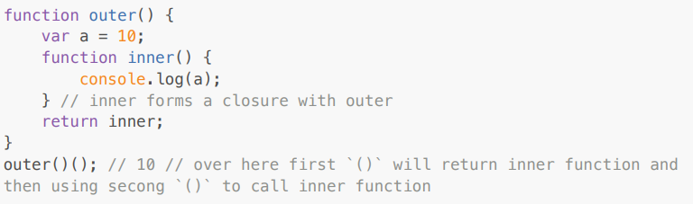

* Will the below code still form a closure?

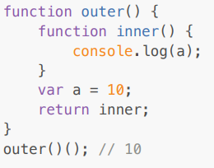

* Ans: Yes, because inner function forms a closure with its outer environment so sequence doesn't matter.
* Changing var to let, will it make any difference?

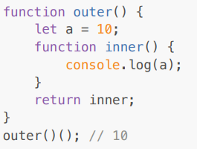

* Ans: It will still behave the same way.
* Q4: Will the inner function have access to the outer function argument?

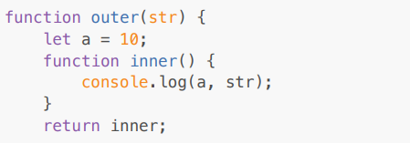

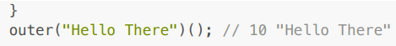

* Ans: Inner function will now form closure and will have access to both a and str.
* Q5: In below code, will inner form closure with outest?

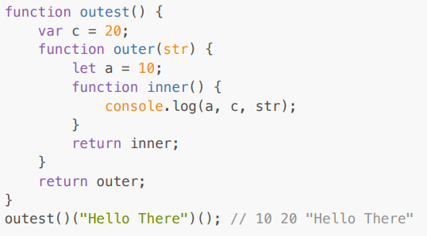

* Ans: Yes, the inner will have access to all its outer environment.
* Q6: Output of below code and explanation?

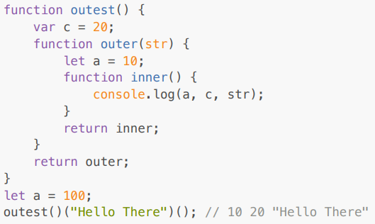

* Ans: Still the same output, inner function will have reference to inner a, so conflicting names won't matter here. If it wouldn't have found an inside outer function then it would have gone more outer to find a and thus have printed 100. So, it tries to resolve variables in the scope chain & if a wouldn't have been found it would have given a reference error.
* Q7: Advantage of Closure? Module Design Pattern Currying Memoize Data hiding and encapsulation setTimeouts etc.
* Q8: Discuss more on Data hiding and encapsulation?

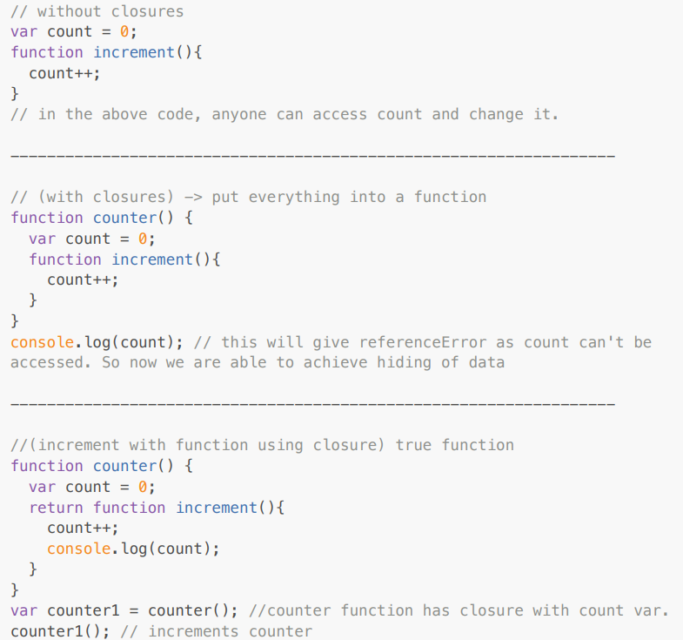

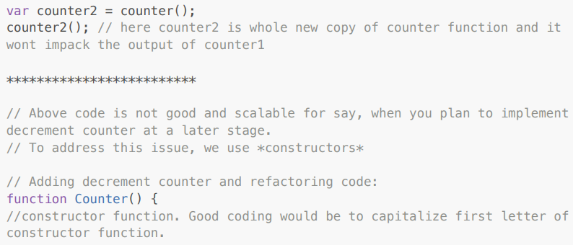

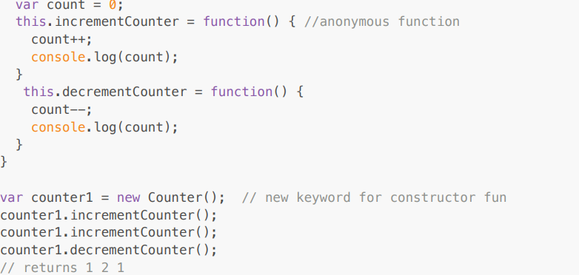

* Q9: Disadvantages of closure?
* Ans: Overconsumption of memory when using closure as every time those closed over variables are not garbage collected till program expires. So when creating many closures, more memory is accumulated and this can create memory leaks if not handled.
* **Garbage collector** : Program in JS engine or browser that frees up unused memory. In high level languages like C++ or JAVA, garbage collection is left to the programmer, but in the JS engine it's done implicitly.

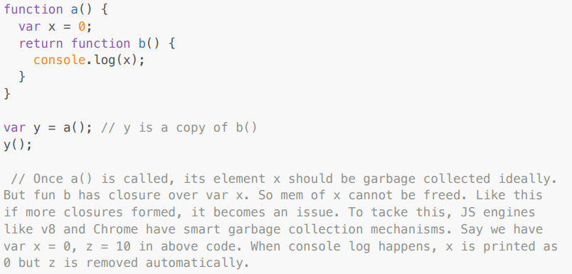

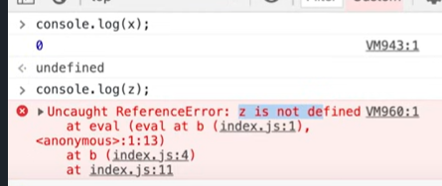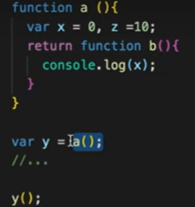

**FIRST CLASS FUNCTIONS**

* **Function statement (Function Declaration)**: Below way of creating function are function statements.

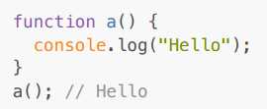

* **Function Expression**: Assigning a function to a variable. Function acts like a value

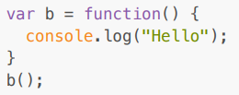

* Difference between function statement and expression: Hoisting.

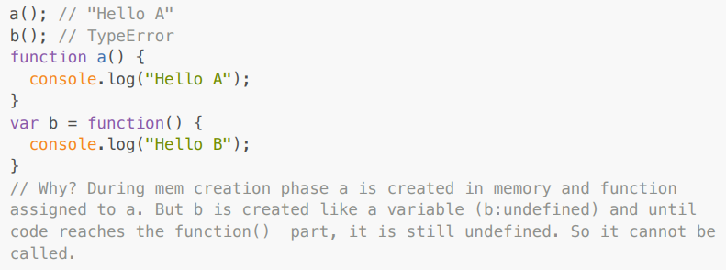

* **Anonymous Function**: A function without a name; They don't have their own identity. So an anonymous function without code inside it results in an error; Anonymous functions are used when functions are used as values eg. the code sample for function expression below

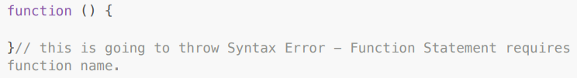

* **Named Function Expression**: Same as Function Expression but function has a name instead of being anonymous.

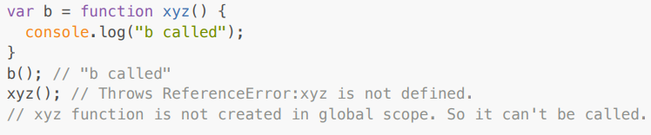

* **Parameters vs Arguments**

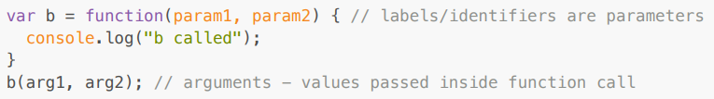

* **First Class Function aka First Class Citizens**: We can pass functions inside a function as arguments and /or return a function(HOF). These abilities are altogether known as First class function. It is a programming concept available in some other languages too.

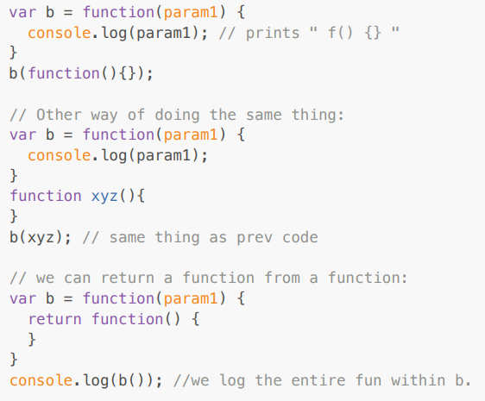

* The ability of functions to be used as values & to be passed as an argument to another function & to be returned from the functions , this ability of fun is known as **first class functions**.

**CALLBACK FUNCTIONS**

* Functions are first class citizens ie. take a function A and pass it to another function B. Here, A is a callback function. So basically I am giving access to function B to call function A. This callback function gives us access to the whole Asynchronous world in the Synchronous world.

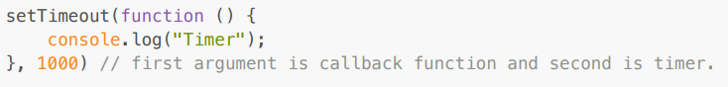

* JS is a synchronous and single threaded language. But due to callbacks, we can do async things in JS.

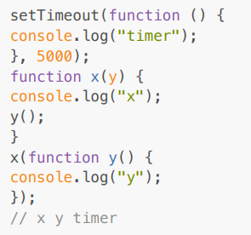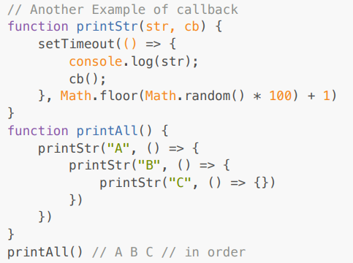

* In the call stack, first x and y are present. After code execution, they go away and the stack is empty. Then after 5 seconds (from beginning) anonymous suddenly appear up in stack ie. setTimeout
* All 3 functions are executed through call stack. If any operation blocks the call stack, it's called blocking the main thread.
* Say if x() takes 30 sec to run, then JS has to wait for it to finish as it has only 1 call stack/1 main thread. Never block the main thread.
* Always use async for functions that take time eg. setTimeout
* We will create a button in html and attach an event to it.

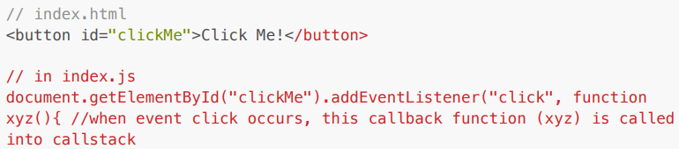



* Lets implement a increment counter button: Using global variable (not good as anyone can change it)

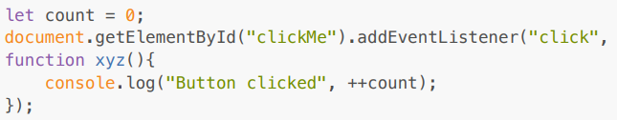

* Use closures for data abstraction

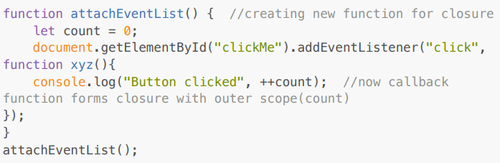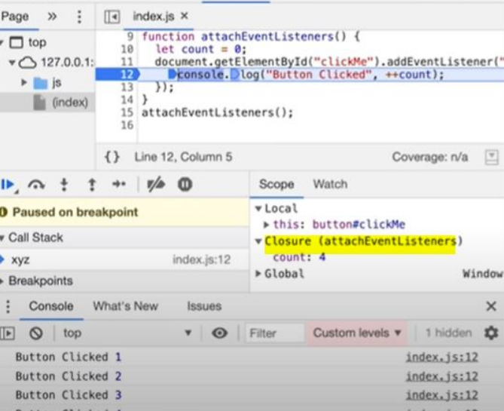

* **Garbage Collection and removeEventListeners:** Event listeners are heavy as they form closures. So even when the call stack is empty, EventListener won't free up memory allocated to count as it doesn't know when it may need to count again. So we remove event listeners when we don't need them (garbage collected) onClick, onHover, onScroll all in a page can slow it down heavily.

**EVENT LOOP**

* Call stack will execute any execution context which enters it. Time, tide and JS waits for none. Call stack has no timer.
* Browser has JS Engine which has Call Stack which has Global execution context, local execution context etc.
* But browsers have many other superpowers - Local storage space, Timer, place to enter URL, Bluetooth access, Geolocation access and so on.
* Now JS needs some way to connect the call stack with all these superpowers. This is done using Web APIs (Browser can have access from other servers i.e DB)

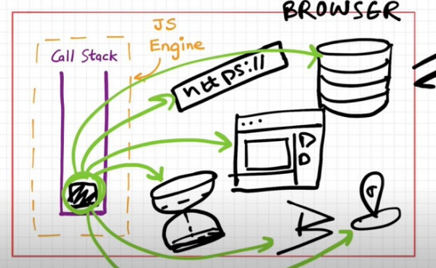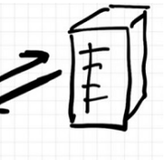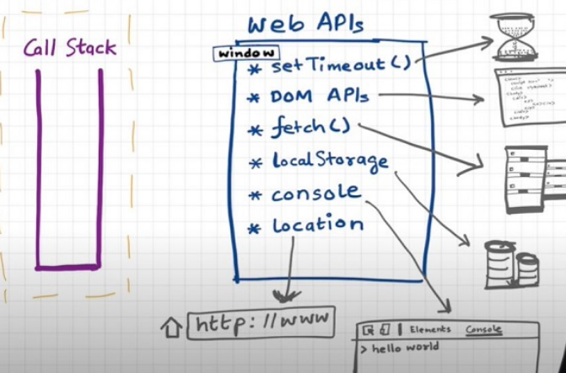

* **Web APIs**: None of the above are part of Javascript! These are extra superpowers that browsers have. Browser gives access to JS call stack to use these powers.
* setTimeout(), DOM APIs, fetch(), localstorage, console, location and so many more; **setTimeout()** : Timer function; **DOM APIs** : eg.Document.xxxx, used to access HTML DOM tree. (Document Object Manipulation); **fetch()** : Used to make connection with external servers eg. Netflix servers etc.
* We get all these inside call stack through global object ie. window
* Use window keywords like : window.setTimeout(), window.localstorage, window.console.log() to log something inside the console.
* As window is global obj, and all the above functions are present in global object, we don't explicitly write window but it is implied.
* Let's understand the below code image and its explanation

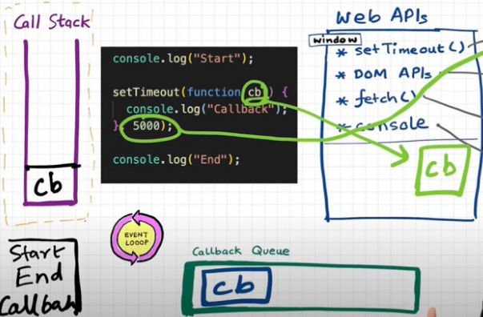

* First a GEC is created and put inside the call stack.
* console.log("Start"); // this calls the console web api (through window) which in turn actually modifies values in the console.
* setTimeout(function cb() { //this calls the setTimeout web api which gives access to the timer feature. It stores the callback cb() and starts the timer. console.log("Callback");}, 5000);
* console.log("End"); // calls console api and logs in console window. After this GEC pops from the call stack.
* While all this is happening, the timer is constantly ticking. After it becomes 0, the callback cb() has to run.
* Now we need this cb to go into the call stack. Only then will it be executed. For this we need an event loop and Callback queue.
* **Event Loops and Callback Queue** Q: How after 5 secs timer is console? cb() cannot simply directly go to callstack to be executed. It goes through the callback queue when the timer expires.
* Event loop keeps checking the callback queue, and sees if it has any element to put into the call stack. It is like a gatekeeper.
* Once cb() is in the callback queue, eventloop pushes it to the call stack to run. Console API is used and log printed.
* Another example to understand Eventloop & Callback Queue.

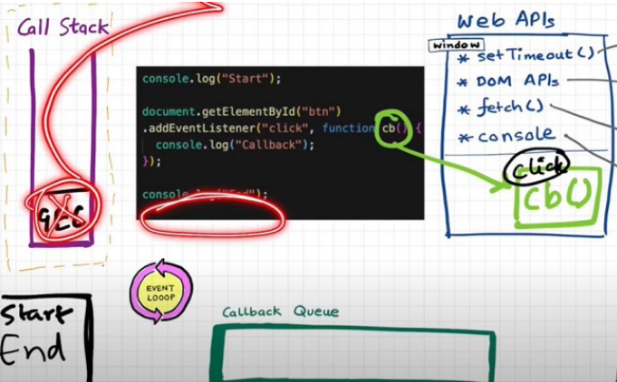

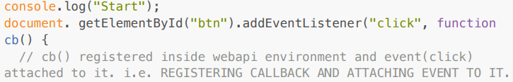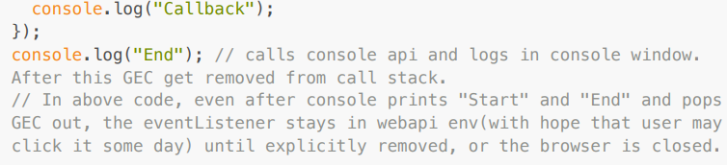

* Eventloop has just one job to keep checking the callback queue and if found something push it to the call stack and delete from the callback queue.
* **Need of callback queue**: Suppose user clicks button x6 times. So 6 cb() are put inside the callback queue. Event loop sees if the call stack is empty/has space and whether the callback queue is not empty(6 elements here). Elements of the callback queue popped off, put in call stack, executed and then popped off from call stack.
* Behavior of fetch (Microtask Queue?)

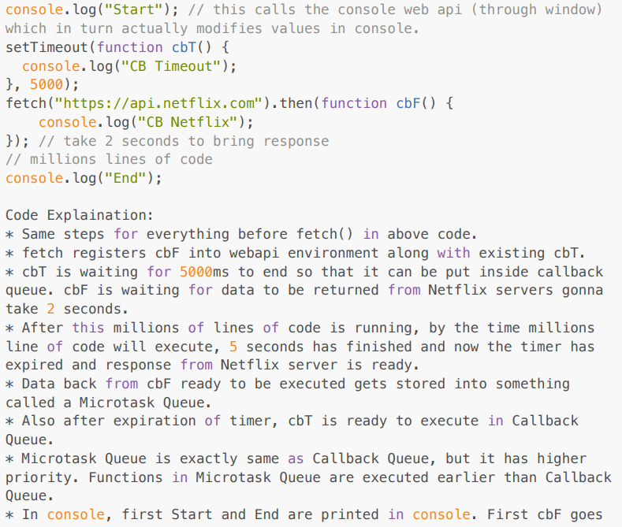

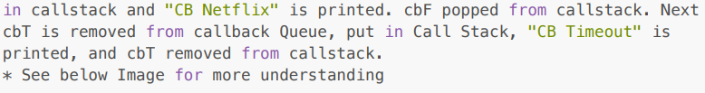

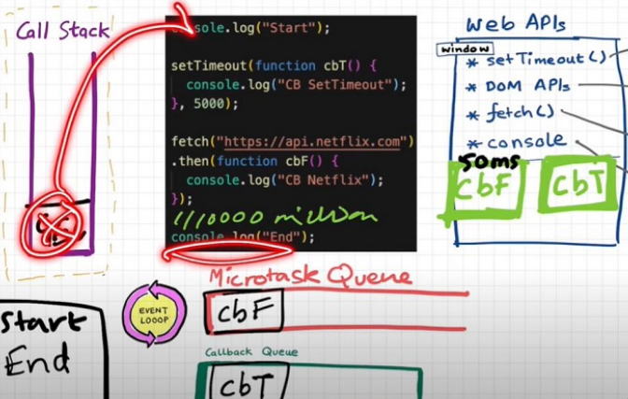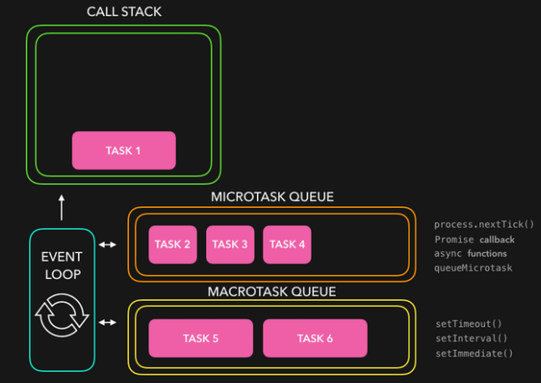

* **What enters the Microtask Queue?**
* All the callback functions that come through promises go in microtask Queue.
* **Mutation Observer**: Keeps on checking whether there is mutation in the DOM tree or not, and if there, then it executes some callback function.
* Callback functions that come through promises and mutation observers go inside Microtask Queue.
* All the rest goes inside Callback Queue aka. Task Queue.
* If the task in the microtask Queue keeps creating new tasks in the queue, the element in the callback queue never gets a chance to be run. This is called starvation
* **When does the event loop actually start?** Event loop, as the name suggests, is a single-thread loop that is almost infinite. It's always running and doing its job.
* **Are only asynchronous web api callbacks registered in the web api environment?** YES, the synchronous callback functions like what we pass inside map, filter and reduce aren't registered in the Web API environment. It's just those async callback functions which go through all this.
* **Does the web API environment store only the callback function and push the same callback to the queue/microtask queue?** Yes, the callback functions are stored, and a reference is scheduled in the queues. Moreover, in the case of event listeners(for example click handlers), the original callbacks stay in the web API environment forever, that's why it's advised to explicitly remove the listeners when not in use so that the garbage collector does its job.
* **How does it matter if the delay for setTimeout would be 0ms. Then the callback will move to the queue without any wait?** No, there are trust issues with setTimeout() . The callback function needs to wait until the Call Stack is empty. So the 0 ms callback might have to wait for 100ms also if the stack is busy.

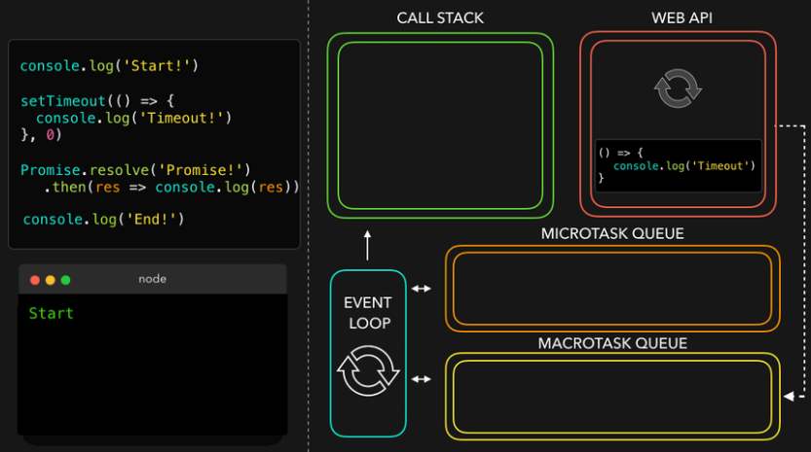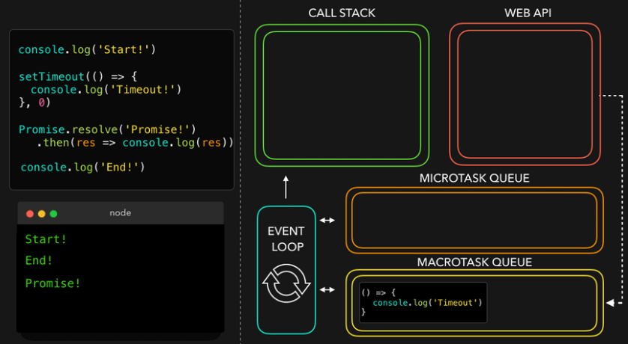

**JS ENGINE**

* JS runs literally everywhere from smartwatch to robots to browsers because of Javascript Runtime Environment (JRE)
* JRE is a big container which has everything which is required to run Javascript code.
* JRE consists of a JS Engine (❤ of JRE), a set of APIs to connect with outside environments, event loop, Callback queue, Microtask queue etc.
* Browsers can execute javascript code because it has the Javascript Runtime Environment.
* ECMAScript is a governing body of JS. It has a set of rules which are followed by all JS engines like Chakra(Edge), Spidermonkey(Firefox)(first javascript engine created by JS creator himself), v8(Chrome)
* **Javascript Engine is not a machine**. Its software written in low level languages (eg. C++) that takes in high-level code in JS and spits out low level machine code.
* Code inside Javascript Engine passes through 3 steps : **Parsing, Compilation and Execution**
* **Parsing** - Code is broken down into tokens. In "let a = 7" -> let, a, =, 7 are all tokens. Also we have a syntax parser that takes code and converts it into an AST (Abstract Syntax Tree) which is a JSON with all key values like type, start, end, body etc (looks like package.json but for a line of code in JS. Kinda unimportant)(Check out astexplorer.net -> converts line of code into AST).
* **Compilation** - JS has something called Just-in-time(JIT) Compilation - uses both interpreter(for speed) & compiler(for efficiency & optimization). Also compilation & execution both go hand in hand. AST from the previous step goes to an interpreter which converts high-level code to bytecode & moves to execution. While interpreting, the compiler also works hand in hand to compile and form optimized code during runtime. Does JS really Compile? The answer is a YES. JS used to be only an interpreter in old times, but now has both to compile and interpret code and this makes JS a JIT compiled language, it's like the best of both worlds.
* **Execution** - Needs 2 components ie. Memory heap(place where all memory is stored) and Call Stack(same call stack from previous episodes). There is also a garbage collector. It uses an algo called **Mark and Sweep.**

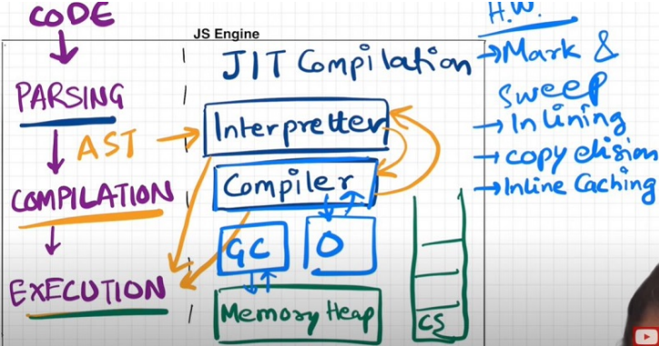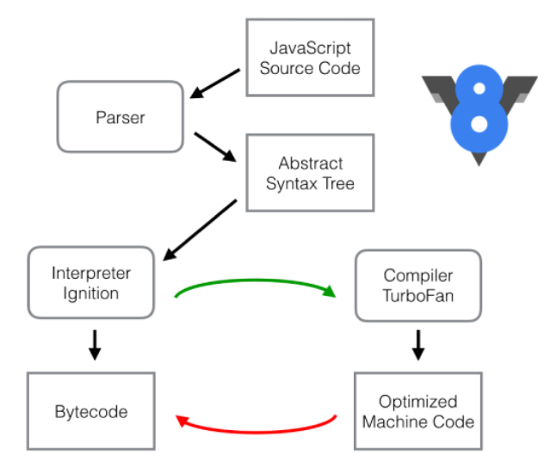

* Companies use different JS engines and each try to make theirs the best.
* v8 of Google has Interpreter called Ignition, a compiler called Turbo Fan and garbage collector called Orinoco; v8 architecture(above)

**SET TIMEOUT**

* setTimeout with a timer of 5 secs sometimes does not exactly guarantee that the callback function will execute exactly after 5s.

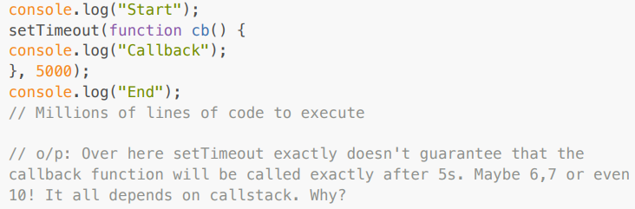

* First GEC is created and pushed in the call stack. Start is printed in the console.
* When setTimeout is seen, the callback function is registered into webapi's env. And a timer is attached to it and started. callback waits for its turn to be executed once timer expires. But JS waits for none. Go to the next line.
* End is printed in the console.
* After "End", we have 1 million lines of code that takes 10 sec(say) to finish execution. So GEC won't pop out of stack. It runs all the code for 10 sec.
* But in the background, the timer runs for 5s. While call stack runs the 1M line of code, this timer has already expired and callback fun has been pushed to Callback queue and waiting to be pushed to call stack to get executed.
* Event loop keeps checking if the call stack is empty or not. But here GEC is still in the stack so cb can't be popped from the callback Queue and pushed to CallStack. Though setTimeout is only for 5s, it waits for 10s until the call stack is empty before it can execute (When GEC popped after 10 sec, callstack() is pushed into the call stack and immediately executed (Whatever is pushed to the call stack is executed instantly).
* This is called the Concurrency model of JS: the logic behind setTimeout's trust issues
* The First rule of JavaScript: Do not block the main thread (as JS is a single threaded(only 1 call stack) language).
* In the below example, we are blocking the main thread. Observe Question and Output.

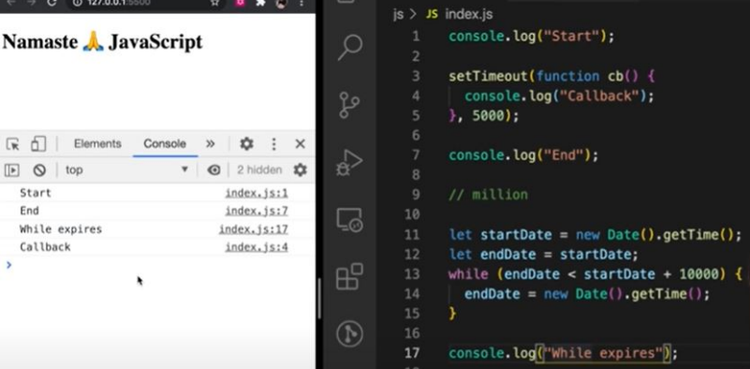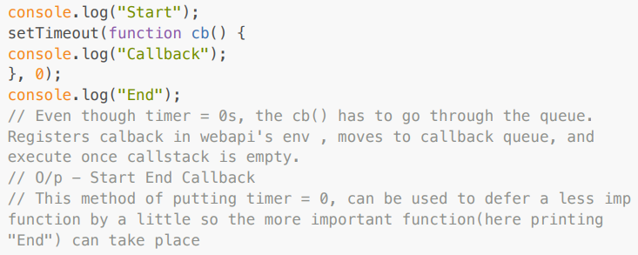

* setTimeout guarantees that it will take at least the given timer to execute the code.
* JS is a synchronous single threaded language. With just 1 thread it runs all pieces of code. It becomes kind of an interpreter language, and runs code very fast inside the browser (no need to wait for code to be compiled) (JIT - Just in time compilation). And there are still ways to do async operations as well.

**HIGHER ORDER FUNCTIONS**

* It is a function that takes other functions as arguments or return functions as their results.
* Let's try to understand how we should approach a solution in an interview. I have an array of radius and I have to calculate the area using these radius and store it in an array.

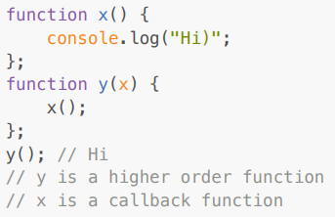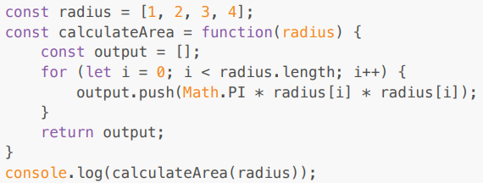

* The above solution works perfectly fine but what if we have a new requirement to calculate an array of circumferences. Code now be like (But it is violating DRY Principle)

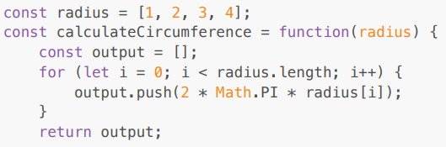

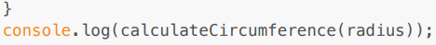

* But over here we are violating DRY Principle, now let's observe the better approach

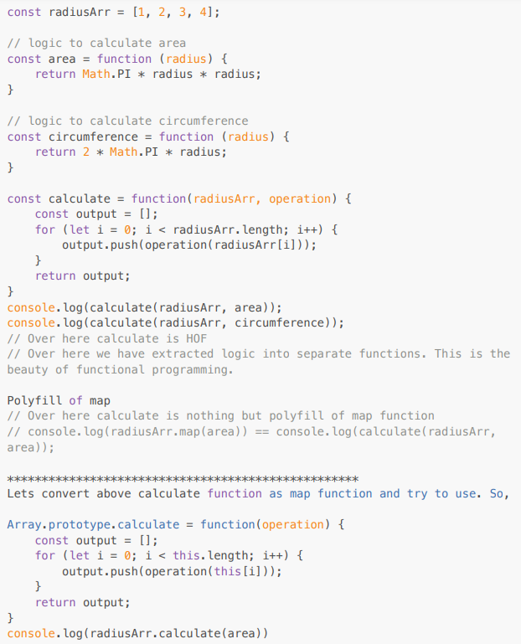

**MAP, FILTER, REDUCE**

* map, filter & reducer are Higher Order Functions.
* **MAP:** It is basically used to transform an array. The map() method creates a new array with the results of calling a function for every array element.
* const output = arr.map(function) // this function tells map that what transformation I want on each element of array

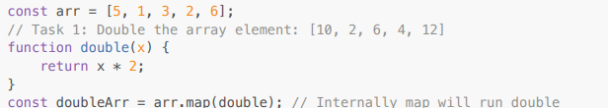



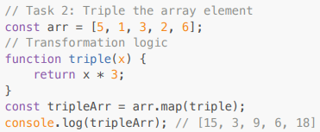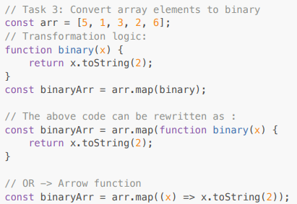

* **FILTER:** It is basically used to filter the value inside an array. The arr.filter() method is used to create a new array from a given array consisting of only those elements from the given array which satisfy a condition set by the argument method.

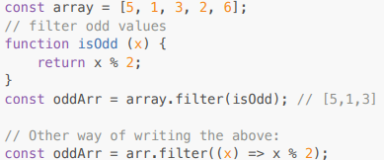

* Filter function creates an array and store only those values which evaluates to true
* **REDUCE:** It is a function which takes all the values of an array and gives a single output of it. It reduces the array to give a single output.

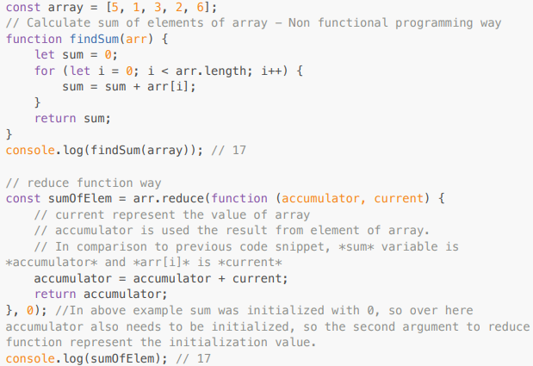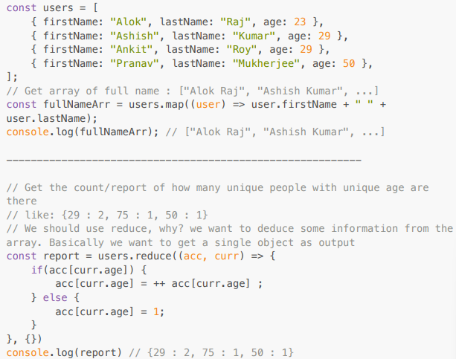

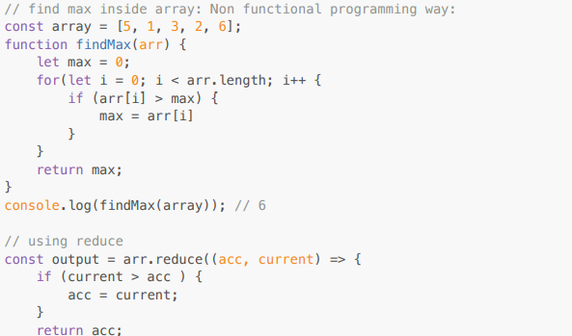

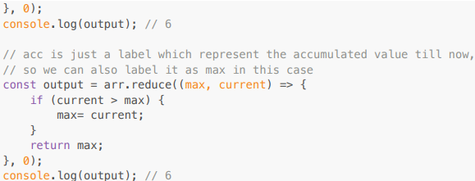

* Function chaining

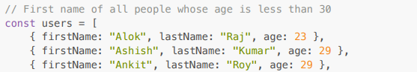

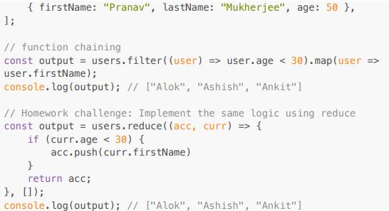

**CALLBACK**

* **Good Part** - Callback is important while writing async code in JS; **Bad Part** - Callback Hell & Inversion of control (IOC-therefore Promises)

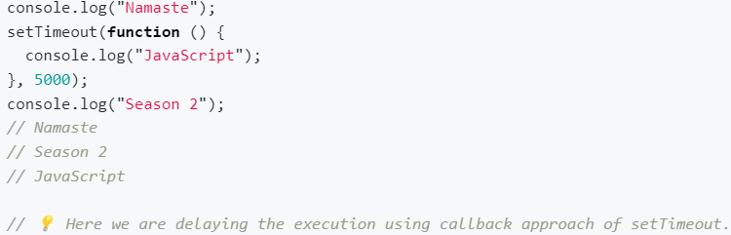

* Assume a scenario of e-Commerce web

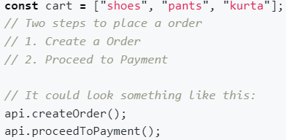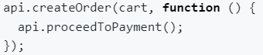

* Assumption, once order is created then only we can proceed to payment, so there is a dependency. So How to manage this dependency? Using Callback
* Over here `createOrder` api is first creating an order then it is responsible to call `api.proceedToPayment()` as part of the callback approach.

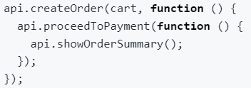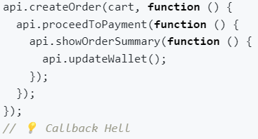

* Now what if we have to update the wallet, now this will have a dependency over showOrderSummary(above)
* When we have a large codebase (unreadable & unmaintainable) and multiple apis and have dependency on each other, then we fall into callback hell. This callback hell structure is also known as the Pyramid of Doom.
* **Inversion of control** is like that you lose the control of code when we are using callback.

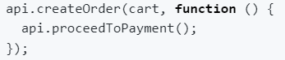

* It is risky, as `proceedToPayment` is an important part of code and we are blindly trusting `createOrder` to call it and handle it. When we pass a function as a callback, basically we are dependent on our parent function that it is its responsibility to run that function. This is called `inversion of control` because we are dependent on that function. What if the parent function stopped working, what if it was developed by another programmer or callback runs 2 times or never runs at all.
* Async programming in JavaScript exists because callback exists.

**PROMISES**

* The Promise object represents the eventual completion (or failure) of an asynchronous operation and its resulting value.

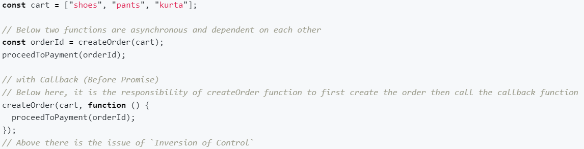

* Now we will make createOrder function return a promise and we will capture that promise into a variable.
* Promise is nothing but we can assume it to be an empty object with some data value in it, and this data value will hold whatever this createOrder function will return.
* Since the createOrder function is an async function, we don’t know how much time it will take to finish execution.
* When createOrder gets executed, it immediately returns a promise object with undefined value. then javascript will continue to execute with other lines of code. After sometime when createOrder has finished execution and orderId is ready then that will automatically be assigned to our returned promise which was earlier undefined.
* How will we get to know the response is ready? By attaching a callback function to the promise object using then to get triggered automatically when the result is ready.

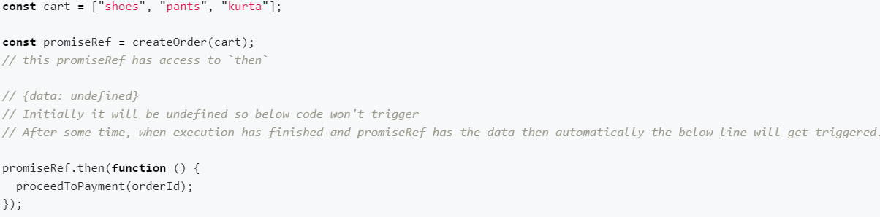

* **How is it better than the callback approach?** In Earlier solution we used to pass the function and then used to trust the function to execute the callback. But with promise, we are attaching a callback function to a promiseObject.
* There is a difference between passing a function and attaching a function. Promise guarantee, it will call back the attached function once it has the fulfilled data. And it will call it only once.
* Fetch is a web-api which is utilized to make api calls and it returns a promise.

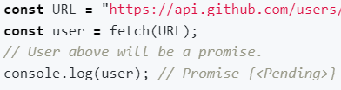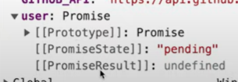

* Promise object has 3 things: prototype, promiseState & promiseResult
* PromiseResult is initially undefined; It will store data returned from API call
* PromiseState will tell in which state the promise is currently, initially it will be in `pending` state and later it will become `fulfilled`.
* When the above line is executed, fetch makes an API call and returns a `promise` instantly which is in `Pending` state and Javascript doesn't wait to get it `fulfilled` And in the next line it console out the `pending promise`.
* Once fulfilled data is there in promiseResult and it is inside the body in ReadableStream format we can extract the data using **.then()**

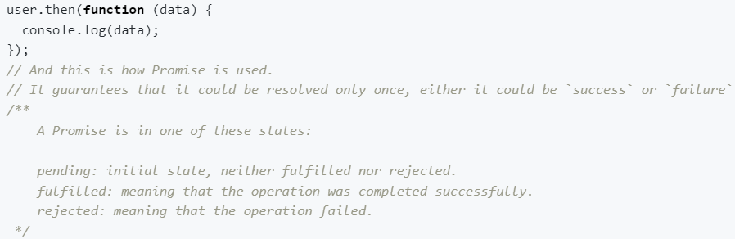

* **Promise Objects are immutable**. We can’t directly mutate the user promise object, control is in our hands.
* A Promise object is a placeholder for a certain period of time until we receive value from asynchronous operation.(A container for a future value) (IOC issue resolved)
* Promise resolves Callback hell issue as well

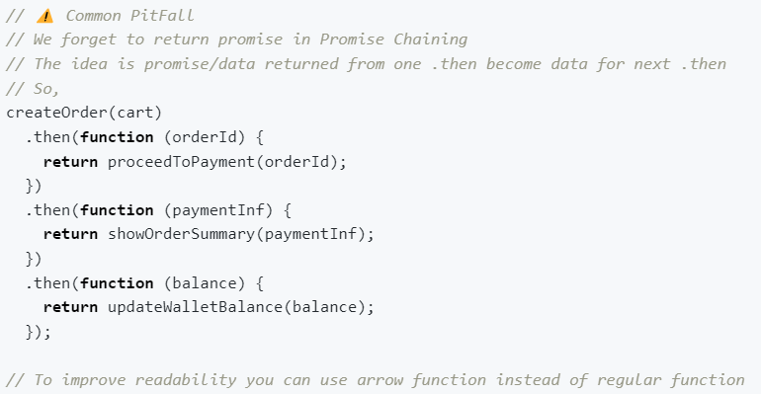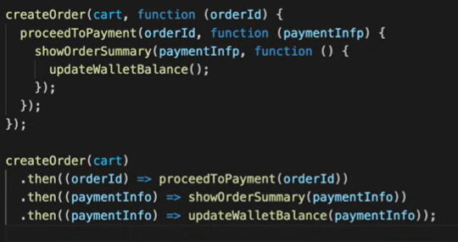

* JS provides a Promise constructor through which we can create promise. It accepts a callback function with two parameters `resolve` & `reject. These are functions which are passed by javascript to us in order to handle success and failure of function calls.

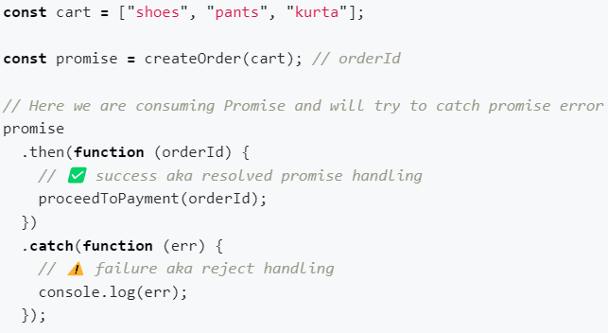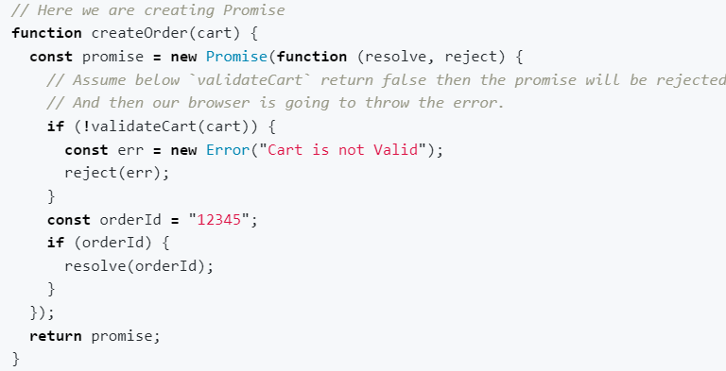

* **Promise Chaining:** Whatever is returned from 1st .then becomes data for next .then and so on.
* At any point of promise chaining, if a promise is rejected, the execution will fallback to .catch and other promises won’t run.

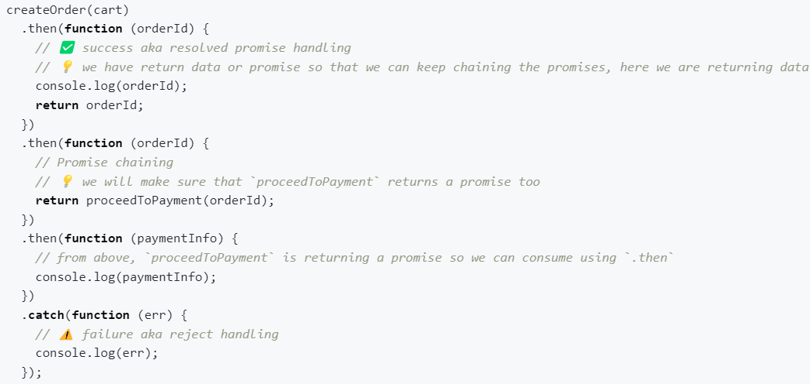

* What if we want to continue execution even if promises are failing, how to achieve this? By placing the .catch block at some level after which we are not concerned with failure.

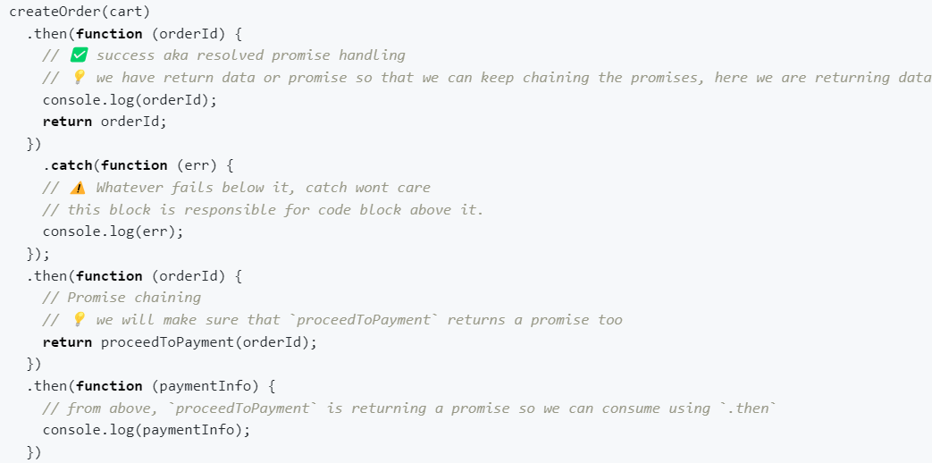

**ASYNC AWAIT**

* Async is a keyword that is used before a function to create an async function.
* **Async function always returns a promise**, even if we return a simple string from async function, async keyword will wrap it under Promise and then return.

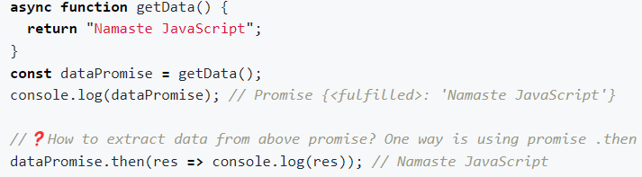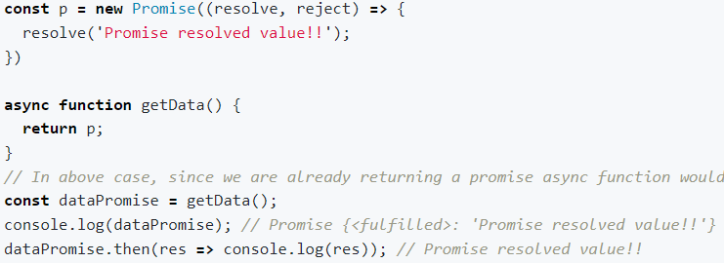

* async and await combo is used to handle promises. Await is used in front of promise. Await keyword can only be used inside an async function.
* But how we used to handle promises earlier and why do we even need async/await?

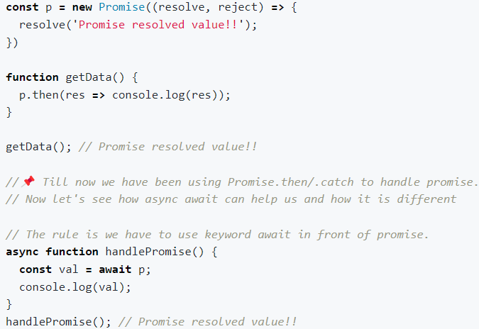

* Below: JS waits for none, so it will register this promise and take this callback function and register separately then js will move on and execute the following console and later once the promise is resolved, the following console will be printed. **JS Engine won’t wait for a promise to be resolved** in the below case**.**

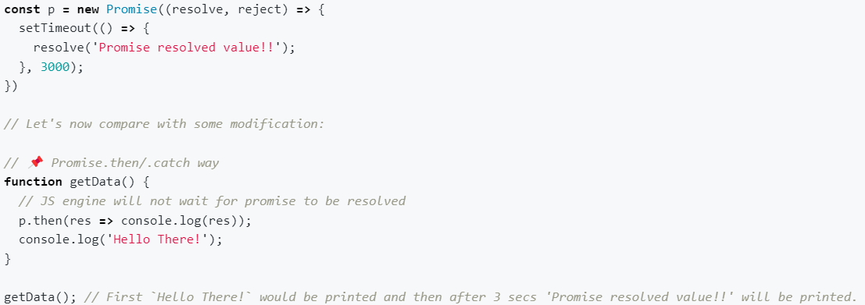

* But in async await, code waits at the `await` line to get the promise resolved before moving on to the next line.

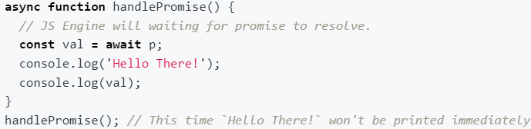

* Let’s see few cases

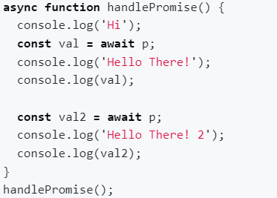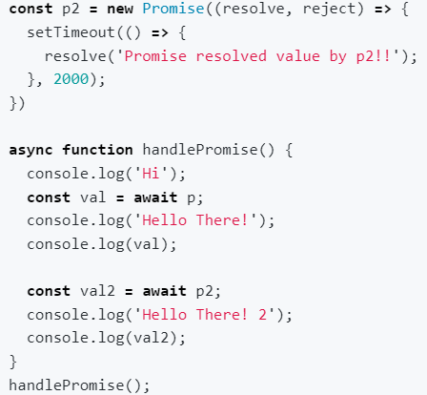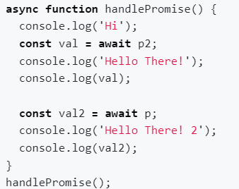

* Case 1: `Hi` printed instantly, code will wait for 3 secs, after 3 secs both promises will be resolved so ('Hello There!' 'Promise resolved value!!' 'Hello There! 2' 'Promise resolved value!!') will get printed immediately.
* Case 2: `Hi` printed instantly, code will wait for 3 secs, after 3 secs both promises will be resolved so ('Hello There!' 'Promise resolved value!!' 'Hello There! 2' 'Promise resolved value by p2!!') will get printed immediately. So even though `p2` was resolved after 2 secs it had to wait for `p` to get resolved.
* Cse 3: `Hi` printed instantly, code will wait for 2 secs, after 2 secs ('Hello There!' 'Promise resolved value by p2!!') will get printed and in the subsequent second i.e. after 3 secs ('Hello There! 2' 'Promise resolved value!!') will get printed.
* Over here it appears that the JS engine is waiting but the JS engine is not waiting over here. It has not occupied the call stack if that would have been the case our page may have got frozen. So the JS engine is not waiting. If it is not waiting then what is it doing behind the scenes?
* In Case 3, call stack flow ⇒ handlePromise() is pushed ⇒ It will log `Hi` to console ⇒ Next it sees we have await where a promise is supposed to be resolved ⇒ will it wait for promise to resolve and block call stack? No ⇒ thus handlePromise() execution get suspended and moved out of call stack ⇒ So when JS sees await keyword it suspend the execution of function till promise is resolved ⇒ So `p2` will get resolved after 2 secs, so handlePromise() will be pushed to call-stack again after 2 secs. ⇒ But this time it will start executing from where it had left. ⇒ Now it will log 'Hello There!' and 'Promise resolved value!!' ⇒ then it will check whether `p` is resolved or not ⇒ It will find since `p` will take 3 secs to resolve so the same process will repeat ⇒ execution will be suspended until the promise is resolved.
* Thus JS is not waiting, the call stack is not getting blocked.
* Fetch API: Gives us a response object which is a readable stream which needs to be converted to json, which is again a promise & which when resolved gives value.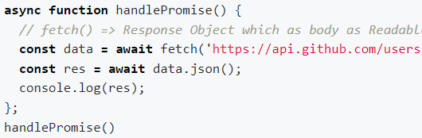
* **Error Handling:** While we were using normal Promise we were using .catch to handle error, now in async-await we would be using try-catch block to handle error.

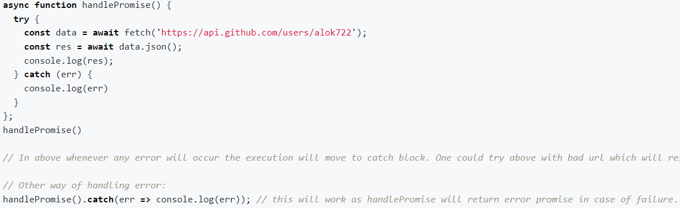

* **Async await vs Promise.then/.catch:** async-await is just a syntactic sugar around promise. Behind the scenes, async-await is just a promise. So both are the same, it’s just async-await is a new way of writing code. async-await solves few of the short-coming of Promises like Promise Chaining. async-await also increases the readability. So sort of it is always advisable to use async-await.

**PROMISE APIS**

* **Promise.all():** A promise is a placeholder for a value that's going to be available sometime later. The promise helps handle asynchronous operations. JavaScript provides a helper function Promise.all(promisesArrayOrIterable) to handle multiple promises at once, in parallel, and get the results in a single aggregate array.
* It is used when we have to make parallel API calls and get the result. It is used to handle multiple promises together.
* Promise.all([p1, p2, p3]) ⇒ Let's assume we are making 3 API calls to fetch data. Also assume p1 takes 3 seconds, p2 takes 1 second, p3 takes 2 seconds.
* In the first scenario let’s assume all 3 promises are successful. So Promise.all will take 3 secs and will give the promise value of the result like [val1, val2, val3]. It will wait for all of them to finish then it will collect the results and give an array as output.
* What if any of the promises gets rejected, for eg: Promise.all([p1, p2, p3]). But this time, p2 got rejected after 1 sec. Thus Promise.all will throw the same error as p2 immediately as soon as the error happens. It will not wait for other promises to either become success or failure. Moreover, **p1 and p2 wont get canceled as they are already triggered so it may result in success or failure depending upon their fate but Promise.all don't care. So it's a situation of all/none**.
* To conclude, the Promise.all() waits for all the input promises to resolve and returns a new promise that resolves to an array containing the results of the input promises. If one of the input promises is rejected, the Promise.all() method immediately returns a promise that is rejected with an error of the first rejected promise.

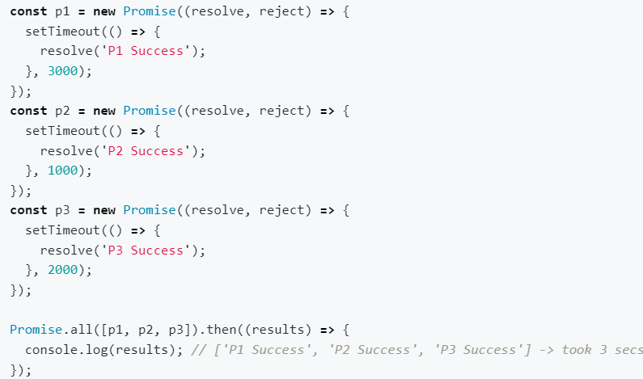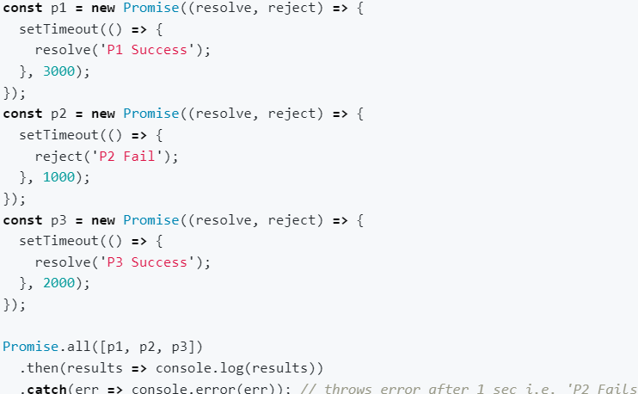

* **Promise.allSettled():** Promise.allSettled() method that accepts a list of Promises and returns a new promise that resolves after all the input promises have settled, either resolved or rejected; **wait for all P’s to settle.** SETTLE means either reject or resolve.
* In the first scenario let’s assume all 3 promises are successful. So Promise.allSettled will take 3secs and will give a promise value of result like [val1, val2, val3]. It will wait for all of them to finish then it will collect the results and give an array as output.
* What if any of the promises gets rejected, for eg: Promise.all([p1, p2, p3]). But this time, p2 got rejected after 1 sec. Thus Promise.allSettled will still wait for all promises to get settled. So After 3 secs, it will be [val1, err, val3] ; It is safest among all.

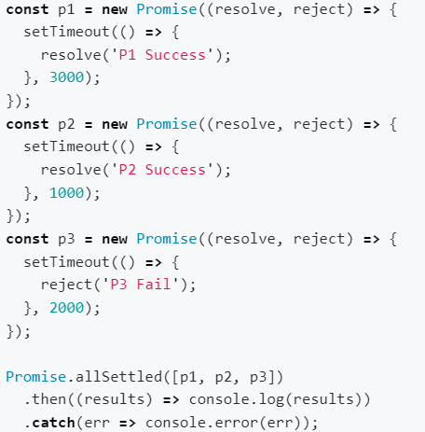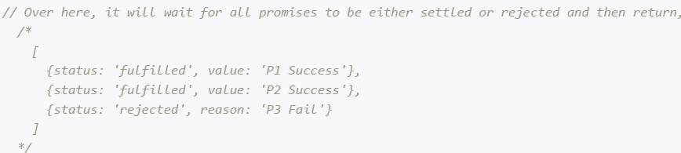

* **P.all() ⇒ Fail Fast; P.allSettled() ⇒ Will wait & provide accumulative result.**
* **Promise.race():** The Promise.race() static method accepts a list of promises as an iterable object and returns a new promise that fulfills or rejects as soon as there is one promise that fulfills or rejects, with the value or reason from that promise. The name of Promise.race() implies that all the promises race against each other with a single winner, either resolved or rejected; **return the result of 1st settled promise**
* As soon as the first promise is resolved or rejected, it will give the output, Promise.race will give (val2) as output after 1 sec as p2 got resolved at the earliest.
* Whereas if it would have been failed Promise.race would have still given output after 1 sec but this time with error.

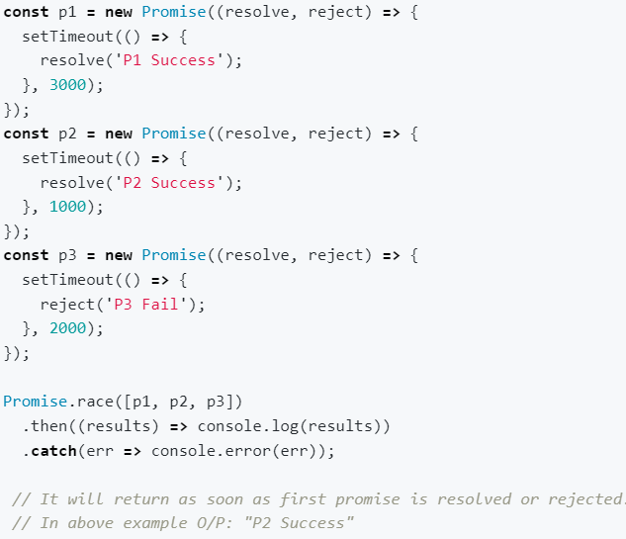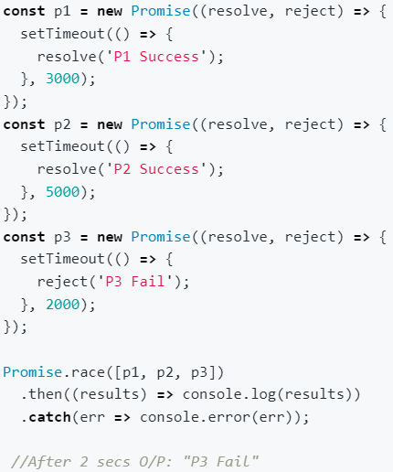

* Once a promise is **settled**, it means ⇒ got the result. Moreover, settled is broadly divided into two categories: resolve/ success/fulfilled & reject/failure/rejected
* **Promise.any():** It accepts a list of Promise objects as an iterable object. If one of the promises in the iterable object is fulfilled, the Promise.any() returns a single promise that resolves to a value which is the result of the fulfilled promise; **return 1st settled resolved/success Promise.**
* As soon as the first promise will be successful, it will give the output.
* If p2 got rejected, nothing will happen as Promise.any seek for success, so the moment first success will happen that will become the result.
* But what if all promises failed, so the returned result will be aggregated error i.e. [err1, err2, err3].

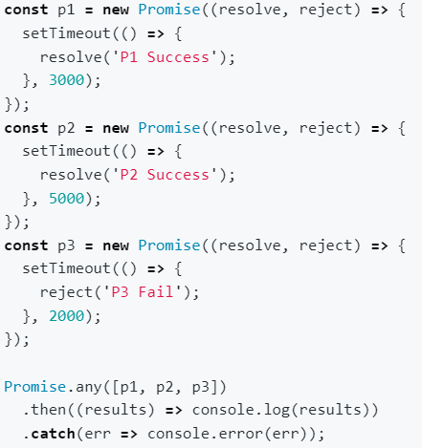

* It will wait for first settled success; In above, p3 will settled first, but since it is rejected, so it will wait further so at 3rd second it will print "P1 Success”

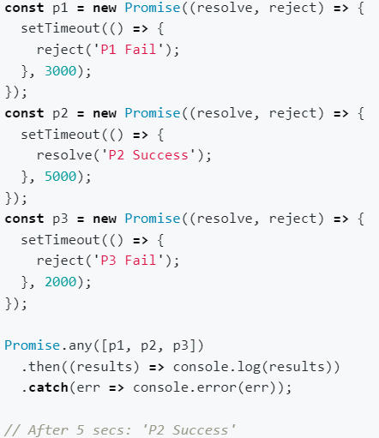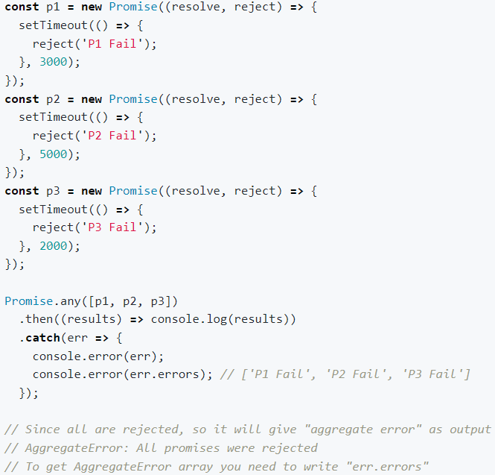

* There are 6 static methods of Promise class
* **Promise.all(promises)**: waits for all promises to resolve and returns an array of their results. If any of the given promises is rejected, it becomes the error of Promise.all, and all other results are ignored.
* **Promise.allSettled**() (recently added method): waits for all promises to settle and returns their results as an array of objects with: status: “fulfilled” or “rejected” value (if fulfilled) or reason (if rejected).
* **Promise.race()**: waits for the first promise to settle, and its result/error becomes the outcome.
* **Promise.any()** (recently added method): waits for the first promise to fulfill, and its result becomes the outcome. If all of the given promises are rejected, AggregateError becomes the error of Promise.any().
* **Promise.resolve(value)**: makes a resolved promise with the given value.
* **Promise.reject(error)**: makes a rejected promise with the given error.

**THIS**

* In JS, this keyword refers to an object, which depends on how this is being invoked (used or called).
* **this in global space:** Anything defined globally is said to be in a global space. In case of browser this is ‘window’ (global object)



* **this inside a function:** On the first go feels like `this` keyword in global space and the inside function behaves the same but in reality it's different. The moment you make JS run in strict mode by using: "use strict" at the top, `this` keyword inside function returns `undefined` whereas global space will still refers to global window object

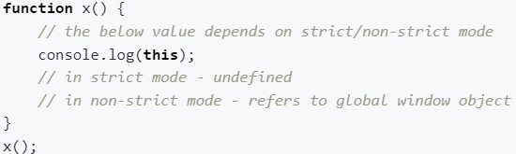

* this substitution ⇒ According to this substitution phenomena, if the value of this keyword is null/undefined, it will be replaced by globalObject only in non-strict mode. This is the reason why this refers to the global window object inside the function in non-strict mode.
* The value of this keyword inside the function is undefined, but because of this substitution in non-strict mode this keyword refers to globalWindowObject and in strict mode it will still be undefined; this keyword value depends on how the function is called.
* If the function is called without any reference to the object then this is undefined. For eg: In strict mode:

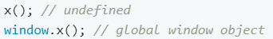

* **this inside an object's method**: If we make a function as a part of an object then it is called a method. x is a method below

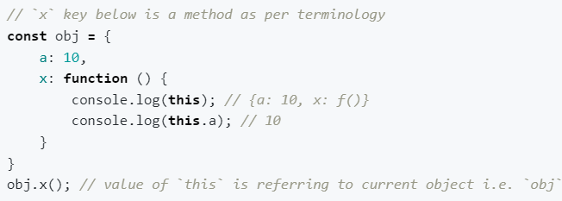

* **call, apply & bind methods:** These are used when we have to share the method (printName is shared with Student2). These methods take this object inside it.

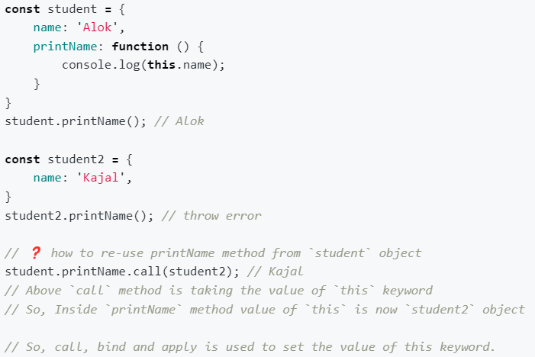

* **this inside arrow function:** Arrow function doesn’t have their own this value, they take the value from enclosing lexical context.

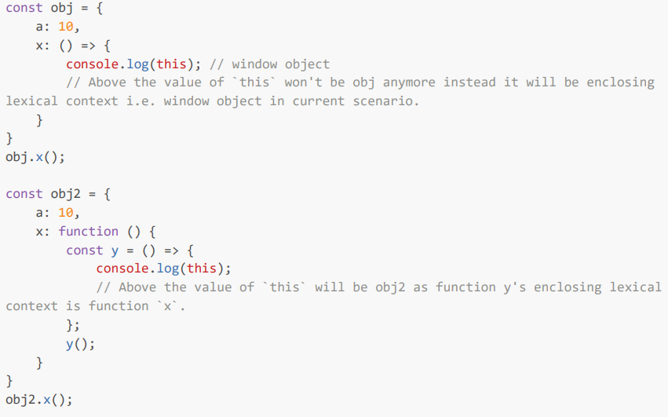

* **this inside DOM**: It refers to an HTML element.

